**Energy Harvesting Tile**

Joamine Lau Xue Min1, and Solahuddin Yusuf Fadhlullah1*

1School of Engineering and Technology, INTI International College Penang, Z-1, Lebuh Bukit Jambul, Bukit Jambul, 11900 Bayan Lepas, Pulau Pinang, Malaysia

*corresponding author: solah.fadhlullah@newinti.edu.my

|  |  |
| --- | --- |
| **ARTICLE HISTORY** | **ABSTRACT** |
| Received  *201X*  Accepted  *201X*  Available online  *201X* | Fossil fuels have caused major environmental issues such as greenhouse effects, global warming and acid rain. Alternatives such as renewable energy which are clean and free are highly recommended to be implemented today. The objectives of this research are to study, designing, improving the performance of power generation through the energy harvesting tile. These are done through identifying the optimum settings for piezoelectric sensors such as the parameters affecting the generation of electricity by piezo elements. In addition, the mechanical design of the tile is also evaluated for maximum operational reliability. To study the behaviour and improve the energy harvesting tile system, analytical modelling using Multisim is developed as a model for optimization. Multiple parameter settings are carried out through this software simulation to verify the reliability of the energy harvesting system. The findings may contribute towards a guideline in development of energy harvesting system based on of piezoelectric sensors. |
| **Keywords:** *Piezoelectric effect; greenhouse effect; ambient energy sources; energy scavenging; optimal setting* |

## 1. introduction

The process of scavenging ambient energy can be done through energy harvesting systems with a source of energy, transducer (energy harvester), power management and energy storage. One of the source of energy is kinetic energy, which comes from vibration.

Kinetic energy can be found easily around us such as from raindrops, waves, footsteps and many more. The techniques used for the conversion of energy would be electrostatic, electromagnetic and piezoelectric. The piezoelectric can be placed underneath the floor tile to collect kinetic energy from footsteps. This floor tile can be installed in places that have high movement density such as railway, shopping malls or schools.

### 1.1 Piezoelectric Transducer

Piezoelectric is defined as creating electricity through pressure. A piezoelectric transducer converts the physical quantity formed by solid material into electrical energy. To further explain this, any mechanical stress and force applied to piezoelectric material will generate electrical voltage. Table 1 shows the type piezoelectric elements and their characteristics.

The piezoelectric transducer (piezo disc) works with principle of piezoelectricity, that is generating electricity with mechanical stress. The piezoelectric material is usually coated with conducting material on the sides of piezoelectric material (such as quartz). Electrical charges of piezoelectric element are balanced with positive charge at one side and negative charge at another side. The atoms will be shifted from one conducting surface to another, affecting the balanced positivity and negativity of systems, hence creating a net electrical charge in system. When this occur, charge is generated, hence electricity is formed.

Table 1: Type of piezoelectric elements and their attributes.

|  |  |  |  |
| --- | --- | --- | --- |
| Type of Piezoelectric Element | Pros | Cons | Author |
| Quartz | High precision | High Cost, Low Sensitivity, Not recommended for piezoelectric power generation | Maghsoudi Nia, E.  Wan Abdullah Zawawi, N. A.  Mahinder Singh, B. S., 2019 |
| PVDF | Flexible, High Mechanical & Chemical Resistance | Bad pure piezoelectric coefficient, Low Curie-Temperature, Necessity to Stretch and Polarizing | Maghsoudi Nia, E.  Wan Abdullah Zawawi, N. A.  Mahinder Singh, B. S., 2019 |
| Mechanically Long Lasting, Low price, Incombustible, Flexible | N/A | Elham Maghsoudi Nia, 2017 |
| PZT | Efficient conversion of mechanical to electrical energy, High Elastic Modulus, High Resonant Frequency | Inorganic, Fragile, loses properties once overstrained | Maghsoudi Nia, E.  Wan Abdullah Zawawi, N. A.  Mahinder Singh, B. S., 2019 |
| N/A | Inorganic ceramic, Brittle, Fragile | Elham Maghsoudi Nia, 2017 |

Piezoelectric materials require some properties and characteristics such as consistent (frequency) stability, high output, malleability, resistance to high temperature and humidity to define its usability in a system. Unfortunately, there is not any one material that holds all the properties stated, hence it is important to choose the right material that possesses the most characteristics for different purpose of design and usage. Generally, quartz crystal is the most primary material where it offers high stability and accuracy but at low output levels and slow measuring at varying parameters.

Piezoelectric elements have the ability to generate an electric charge when compressed with external stress. These elements are known as piezoelectric crystals of two types, direct piezoelectric effect and converse effect. Direct piezoelectric effect converts mechanical stress to electrical charge whereas the converse effect converts electrical potential energy to mechanical strain energy.

Quartz is a crystal ceramic that is made of silica with high precision and acoustic quality. It has a relatively low acoustic loss, but it cost much more than other piezoelectric elements such as PZT ceramics. On top of that, the Quartz crystal has lower charging sensitivity than PZT that causes the unfavourable resolution of quartz charge mode sensors [1].

Polyvinylidene fluoride (PVDF) is a polymeric material that can be purchased at a low price. It is malleable and has a high resistance to mechanical stress hence it can last longer in a harsh environment due to its rigid physical build. PVDF is also incombustible, fire and chemical resistant but it has relatively low Curie-Temperature [2]. Despite this, it has to be shaped through stretching and polarization has to be done.

Lead Zirconate Titanate (PZT) is a piezoceramic material that is mainly used for piezoelectric power generation such as a piezo actuator or sensor along with PVDF. PZT has an advantage of a high electromechanical coupling effect hence it is efficient for the conversion of mechanical energy to electrical energy. PZT is mechanically much more elastic and has a higher resonant frequency as compared to PVDF. Although it is elastic, PZT is considered fragile due to its inorganic ceramic properties and has to be protected from harsh conditions and external mechanical force. It easily loses its piezoelectric properties once it has been overstressed. To overcome this issue, there are multiple methods such as fibre geometries and embedding PZT in epoxy [3].

## 2. MethodologY AND IMPLEMENTATION

### 2.1 Building Blocks of Energy Harvesting System

Figure 1 shows the building blocks of the energy harvester. The input energy is in the form of kinetic energy, such as footsteps in this case, will trigger the energy harvester to output electrical energy which usually is in the form of AC. The AC will be converted to DC through a conversion circuit known as rectifiers. A capacitor is used to reduce ripples or store partial charges from piezo and release it when necessary. A voltage regulator is used to regulate the output voltage to a constant value regardless of any changes in the input voltage. Finally, the output can be connected to loads or storage for future use.

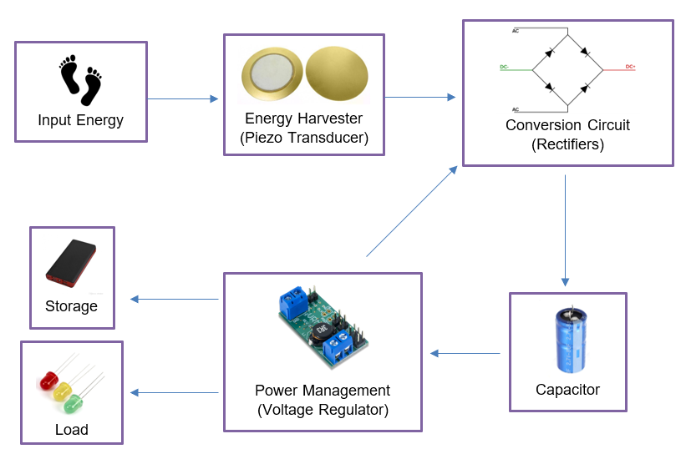

Figure 1: Block diagram of the Proposed Energy Harvesting System

### 2.2 Energy Harvesting Tile

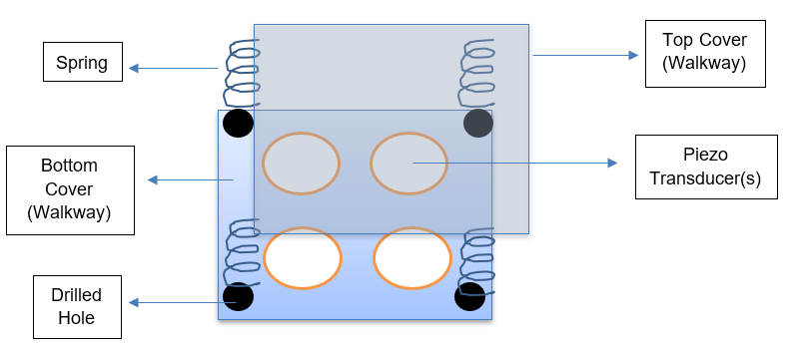

Figure 2: Energy Harvesting Tile Prototype

The design prototype of the walkway is shown in Figure 2. The piezo disc is glued to the covers of walkways, with its top middle surface filled with hot glue. The hot glue is used to provide extra tension and pressure point on the piezo disc so that it can generate higher voltage and increase the efficiency of the system. A sponge tape is also attached to the bottom of the piezo disc to heighten the piezo, hence creating a potential to bend freely on the tile (Figure 3). The mechanism is shown in Figure 4.

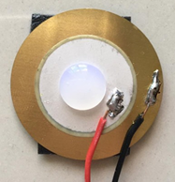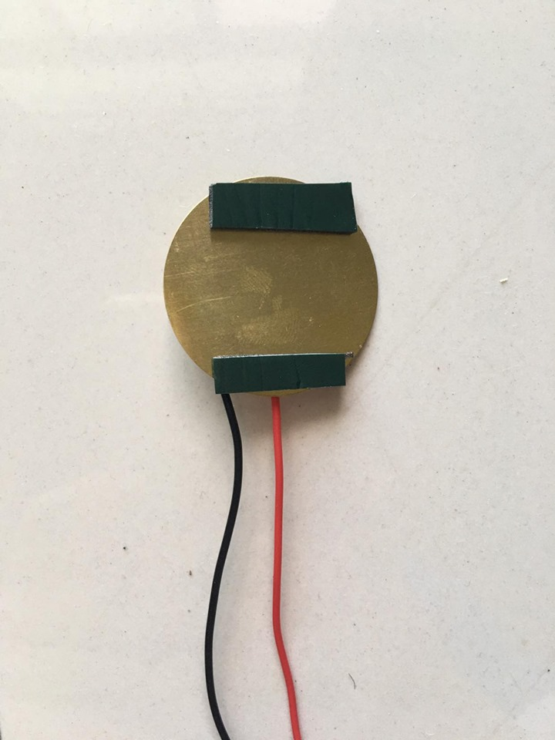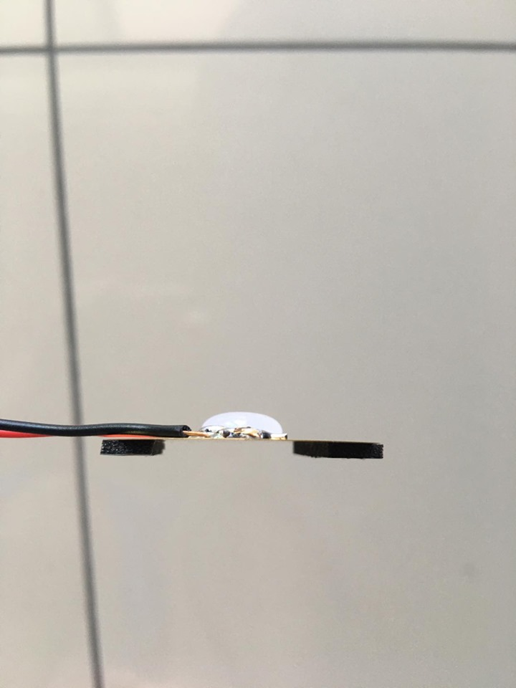

Figure 3. Top, bottom and side view of the piezo disc

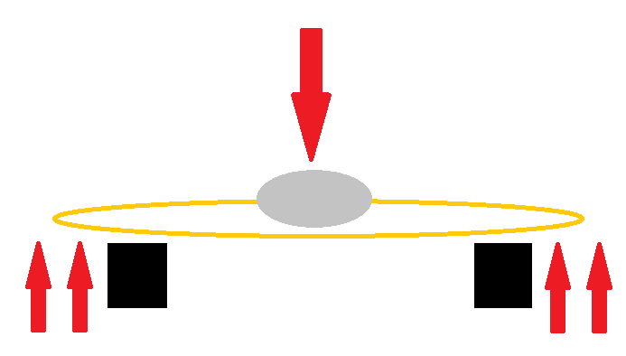 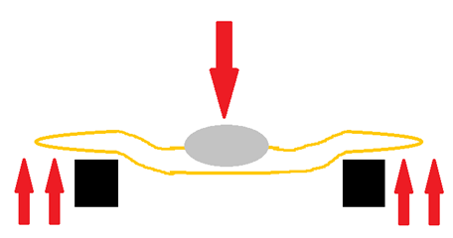

1. (b)

Figure 4. (a) When no stress applied to the piezo disc, it remains flat. (b) When stress is applied, the glue will push the centre of piezo inwards while the foam tape supports the piezo (from the side) and push it upwards after.

***2.3 Implementation***

Figure 5 shows the schematic of the LTC3588 energy harvesting module which can functions as a harvester or regulator where only small amount of input energy is needed to output constant voltage. Whereby Figure 6 shows the proposed design. Rectifier W06M is used for each piezo disc to convert each AC output of the piezo discs to DC output. For measurement and verification purposes, the output of the tile is connected to an Arduino so that the LCD screen can show the amount of power being generated.

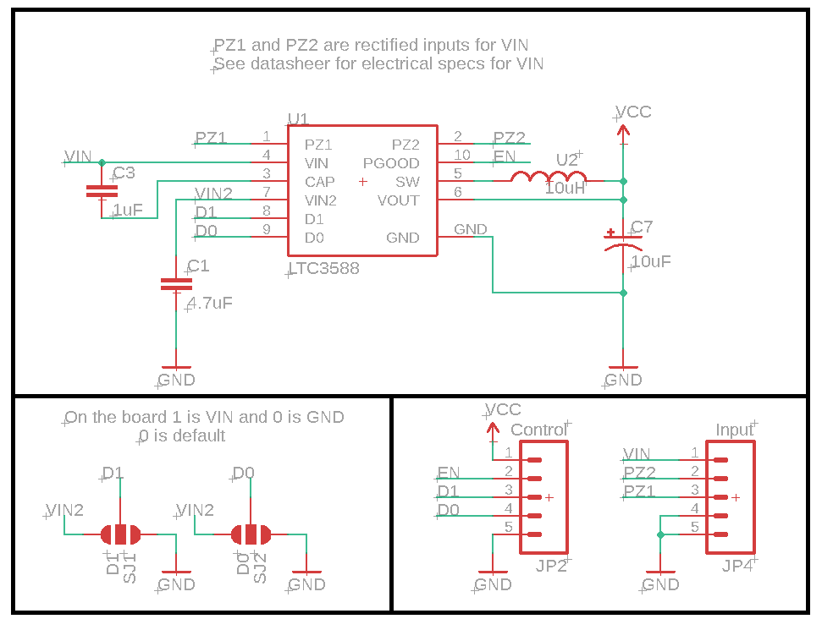

Figure 5: Schematic of the energy harvesting module

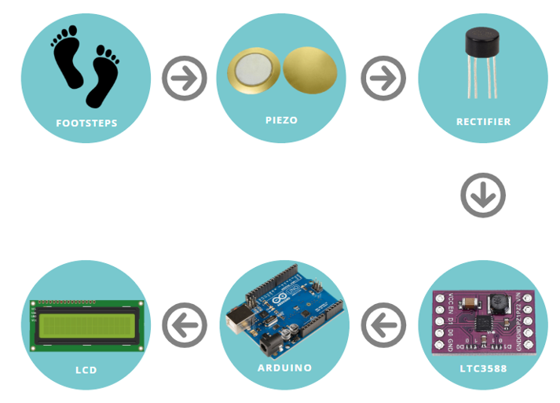

Figure 6: Block diagram of Proposed Prototype Design

## 3. RESULTS AND DISCUSSION

### 3.1 AC Voltage Generated by Piezo Disc

### 3.2 DC Voltage Generated by Piezo Disc

### 3.3 Time Interval (Profile Parameter)

### 3.4: Weight (Profile Parameter)



### Part E: Piezo Arrangement (Profile Parameter)

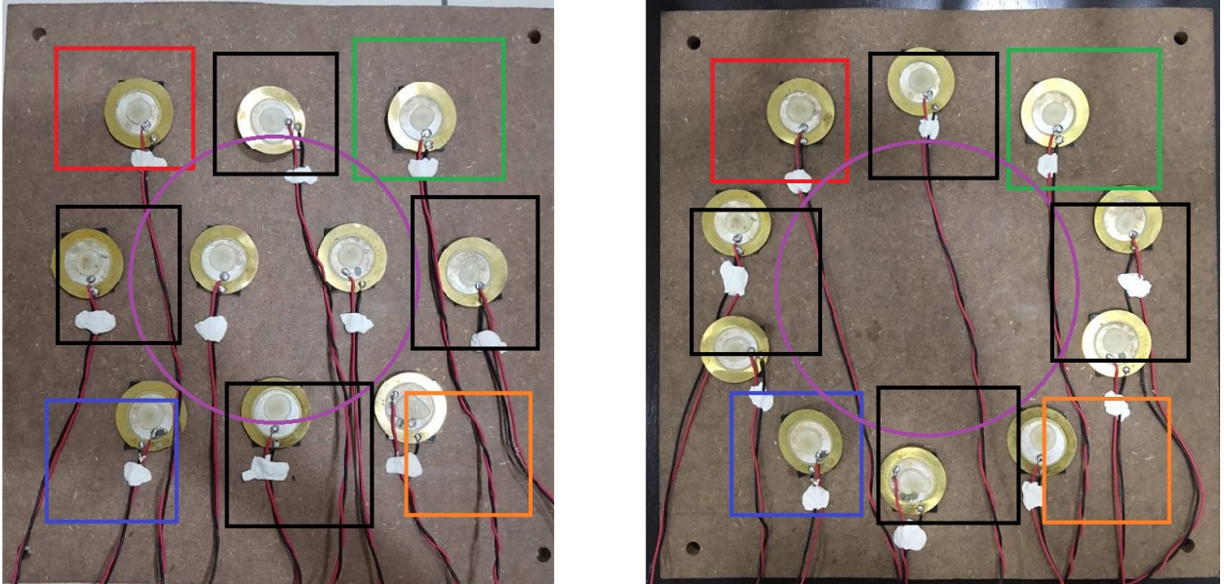

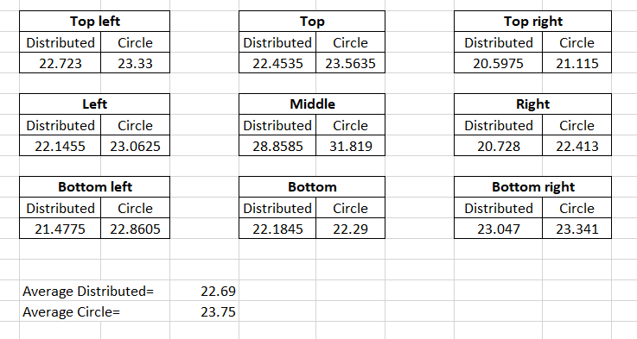

### Summary of Results

### 3.1 Proposed Design

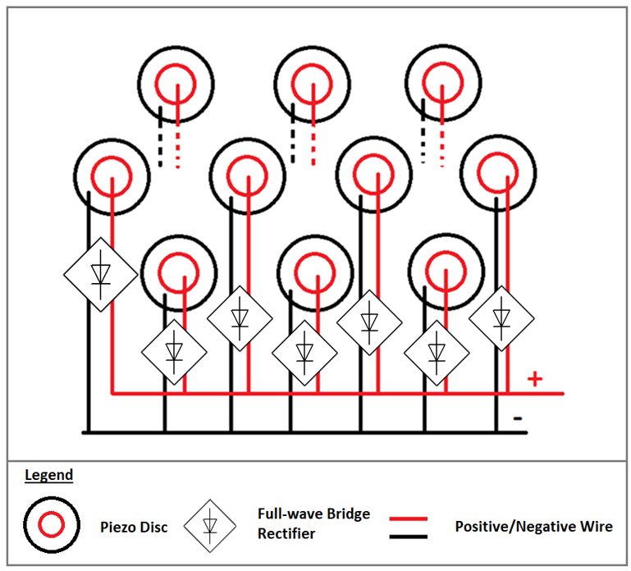

|  |  |
| --- | --- |
| **Specification** | |
| Circuit Connection | Parallel DC |
| Voltage Generation (of tile) | ~21.213Vrms, ~30Vdc |
| Power Generation (of tile) | 20uW |
| Cost | RM15 |

### 3.2 Profile Table of Walkway User

|  |  |  |
| --- | --- | --- |
| **Parameter** | **Testing values** | **Optimum** |
| Rate of Steps | 0.5secs, 1.0secs, 2.0secs | 0.5seconds |
| Weight | 6 Kg, 10Kg, 44Kg | >44Kg |
| Piezo Distribution | Circle distribution, Even distribution | Circle Distribution (with generation of 28V) |

## 4. CONCLUSION

The research was able to complete within the given timeframe and achieving all the 3 objectives although there are still a lot of improvements that can be made in this project.

The research made has the outcome of a profile table of walkway users and a prototype product that can generate 21Vrms of energy. The prototype product was created after multiple studies, testing and design improvements. The profile table is completed through testing different parameters affecting the energy harvesting tile.

The energy harvesting tile could be a solution to the world’s greenhouse effect as it is renewable and free energy. Comparing to burning of fossil fuels, energy harvesting tile leaves no trail and carbon footprints. Hence, when widely used in the future, it could bring a greener world to human beings.

## REFERENCES

Beeby, S.P., M.J. Tudor, and N. White, Energy harvesting vibration sources for microsystems applications. Measurement science and technology, 2006. 17(12): p. R175.

[2] Bischur, E. and N. Schwesinger. Energy harvesting from floor using organic piezoelectric modules. In

Power Engineering and Automation Conference (PEAM), 2012 IEEE. 2012. IEEE.

Canadian Centre for Occupational Health and Safety, 2015.

Clark, B. (n.d.). Pavegen tiles harvest energy from footsteps. Gizmag | New and Emerging Technology

News. Retrieved November 23, 2011, from http://www.gizmag.com/pavegen-tiles- kinetic-energy-

harvesting/20235/

[3] Elvin, N. G.; Lajnef, N.; Elvin, A. A. Feasibility of structural monitoring with vibration powered sensors.

Smart Mater. Struct. 2006, 15 (4), 977.

H. W. Kim, A. Batra, S. Priya, K. Uchino, D. Markley, R. E. Newn-ham, and H. F. Hofmann, “Energy

harvesting using a piezoelectric ‘cymbal’ transducer in dynamic environment,” Jpn. J. Appl. Phys., vol.

43, pp. 6178–6183, Sep. 2004.

Maas, W., 2009.

Mackay, Alan Lindsay. The Harvest of a Quiet Eye: A Selection of Scientific Quotations. Bristol:

Institute of Physics, 1997.

Maghsoudi Nia, Elham & Wan Abdullah Zawawi, Noor Amila & Singh, B.S. (2019). Design of a

pavement using piezoelectric materials. Materialwissenschaft und Werkstofftechnik. 50. 320-328.

10.1002/mawe.201900002.

[1] Mohammadi, M. M. A Comparison Between Quartz and Pzt Ceramic for Sensoric Applications. Int. J.

of Sci. Technol. 2013, 2 (4), 321.

Moskowitz L.R., Permanent magnet design and application handbook, 1995, 2nd ed. Malabar, Fla.:

Krieger.

Pasquale, G. D., (2013) Energy harvesters for powering wireless systems. Energy harvesters for

powering wireless systems.

Romero, E., R. Warrington, and M. Neuman, Energy scavenging sources for biomedical sensors.

Physiological measurement, 2009. 30(9): p. R35.

Shrimoyee Poddar, Mohuya Dutta, Debashree Chowdhury, Abhinaba Dey, Debasis Maji Footstep

Voltage Generator using Piezo-Electric Transducers in Internation Journal of Scientific & Engineering

Research, Volume 8, Issue 3, March-2017 ISSN 2229-5518

Vanz, E.; Karakiewicz, J. In Computer-Aided Architectural Design Futures. The Next City-New

Technologies and the Future of the Built Environment; Springer, 2015.

Zhang, Q., Y. Wang, and E.S. Kim, Power generation from human body motion through magnet and

coil arrays with magnetic spring. Journal of Applied Physics, 2014. 115(6): p. 064908.