**People Counting using Wi-Fi 4**

Eugene Ong Hsien Tze1, Solahuddin Yusuf Fadhlullah1,* Samihah Abdullah2 and Shabinar Abdul Hamid2

1School of Engineering and Technology, INTI International College Penang, Z-1, Lebuh Bukit Jambul, Bukit Jambul, 11900 Bayan Lepas, Pulau Pinang, Malaysia

2Faculty of Electrical Engineering, Universiti Teknologi Mara Pulau Pinang, 13500 Permatang Pauh, Pulau Pinang, Malaysia

*corresponding author: solah.fadhlullah@newinti.edu.my

ABSTRACT

We present a medium scale wireless-based people counting, for up to, but not limited to, a thousand devices or people. A Wi-Fi scanning tool is utilized to capture Wi-Fi packets from active devices. These Wi-Fi enabled devices are connected seamlessly to multiple routers inside a 6 story building, but registered to the same SSID. To differentiate between different and multiple device types (for example, a single person could carry two mobile phones and a laptop simultaneously), a survey was conducted on the building occupants to determine usage trends. From the survey, an algorithm is proposed which would predict the number of people within the area of interest. Empirical results show an accuracy of up to 71.3 % for detecting around 100 people. The method presented would provide a practical estimation on the number of people based on the widely available Wi-Fi technology.

**Keywords:** 802.11n; WiFi; people counting; crowd estimation; crowd prediction

Introduction

In 2018, in an attempt to simplify the Wi-Fi naming standard, Wi-Fi Alliance has rebranded the IEEE 802.11n to Wi-Fi 4. Increments to the number would indicate an upgrade to previous versions, with the upcoming 802.11ax to be marketed as Wi-Fi 6.

Crowd counting using radio frequency is now common. Fundamentally, the signals from wireless activated devices are collected and an algorithm is then applied to normalize and thereby predict the crowd size. However, the methods and practicality differs from small to large scale predictions.

Table 1 tabulates the more recent work on using wireless technology to head count or estimate the crowd density. Depatla & Mostofi (2018) and Kura, Shiraishi & Yamaguchi (2018) have similar methods in counting people where at least a pair of Wi-Fi transceivers are strategically placed to detect variations of Received Signal Strength Indicator (RSSI) when people pass through between them. However, scalability becomes a problem as this method requires huge number of transceivers to acquire visibility in larger areas. The method used by Tang, Xiao and Li (2018) may partly solved the scalability problem where passive probing is utilized; a single probe could capture multiple signals from devices. However, it could not differentiate between different type of devices (mobile phones, laptops and tablets) and would consider each device as one person which may not be true as people may concurrently carry multiple devices with them. The crowd size detection carried out by Yang, Yin and Zhang (2017) is too small; only up to 4 people.

**Table 1: Recent Works in People Counting using Wireless Technologies**

|  |  |  |
| --- | --- | --- |
| Related Works | Features | Limitation(s) |
| Depatla and Mostofi (2018) | Uses pairs of Wi-Fi transceivers to characterize changes in RSSI for crowd speed and occupancy. | * Small detection coverage of less than 5 meters for each Wi-Fi pair. * Small crowd size of up to 20 people. * The crowd needs to pass through a dedicated test area for head counting. |
| Kura, Shiraishi and Yamaguchi (2018) | Similar to Depatla & Mostofi (2018), pairs of Wi-Fi transceivers are utilized to collect the RSSI information. Machine learning and pedestrian count are them performed. | * Small detection coverage of less than 3 meters for each Wi-Fi pair. * Small crowd size of up to 4 people. * The crowd needs to pass through a dedicated test area for head counting. |
| Tang, Xiao and Li (2018) | Passively monitor Probe Request packets from Wi-Fi enabled devices. From the developed algorithm, the information of positioning is determined to predict the crowd density. | * Assumed that all Wi-Fi enabled devices were mobile phones, either single or multiple usage. |
| Yang, Yin and Zhang (2017) | Uses Convolutional Neural Network to analyze and classify the radar signal to indicate presence and count the number of people. | * Small crowd size detected, up to 4 people |

Apart from these, earlier research on small to medium scale crowd size estimation can be traced back to the works of Yuan (2014), Yuan, Zhao, Qiu and Xi (2013), Xu et al. (2013), Xi et al. (2014), Haochao et al. (2015) and Hiroi, Shinoda and Kawaguchi (2016) which used Wi-Fi and/or Bluetooth technology. We have also contributed to the same effort of estimating crowd density (Fadhlullah & Ismail, 2016, 2017). Figure 1 shows several deployment strategies for the aforementioned research. Evidently, all of these strategies could only cater to a small number of people detection, which is below 50.

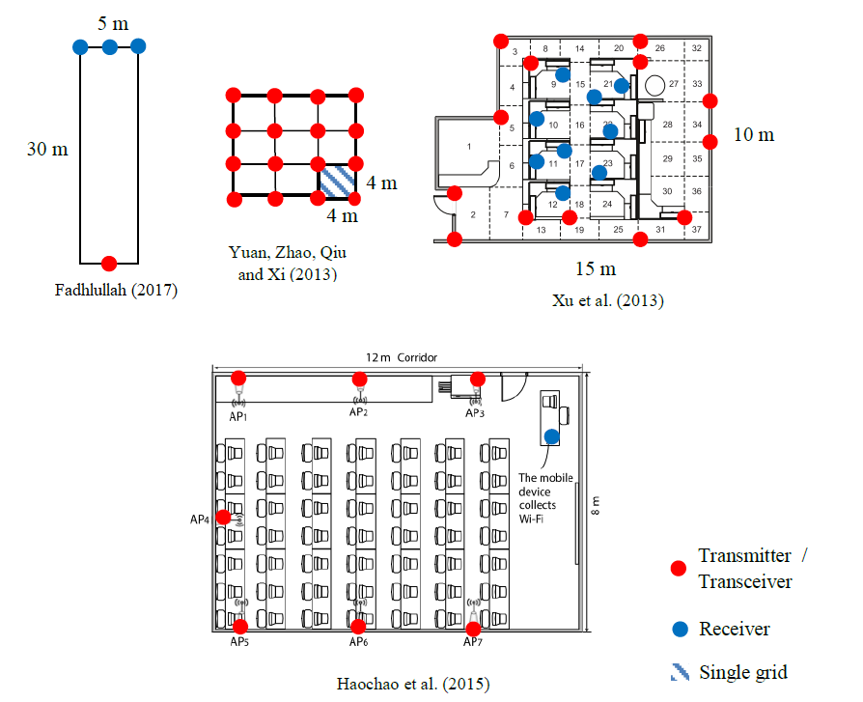

**Figure 1: The placements of wireless transmitters and receivers versus the detection area for people counting (Fadhlullah, 2017)**

On the other hand, large scale outdoor crowd counting majorly relies on participatory sensing; where people counting is done based on the number of detected device carried by each person. Then, the prediction accuracy is improved by methods of statistics or fitting. Such technique is employed by Weppner et al. (2014) and Versichele et al., (2012a, 2012b) by detecting the number of Bluetooth-enabled mobile phones. Their survey campaign is shown in Figure 2, 3 and 4 respectively. However, as users do not typically enable Bluetooth by default, thus the accuracy is still severely lacking where the actual number of people versus device detection is less than 15 %.

As Wi-Fi is nowadays a must for the modern society, it is therefore the most suitable platform for wireless-based people counting compared to other methods such as Bluetooth or active RIFD. Worse, the latter would also consume high level of resources for practical deployment. In contrast, Wi-Fi based signal detection would simply leverage on the daily usage of Wi-Fi in common areas.

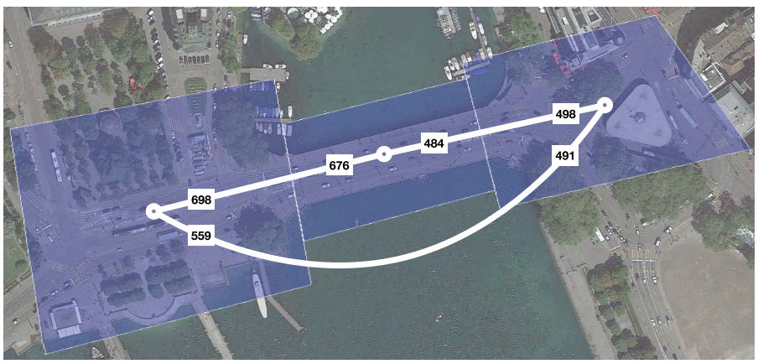

**Figure 2: The number of Bluetooth devices detection (within the blue region) on the Quaibridge, Zurich during a city-wide festival (Weppner et al., 2014)**

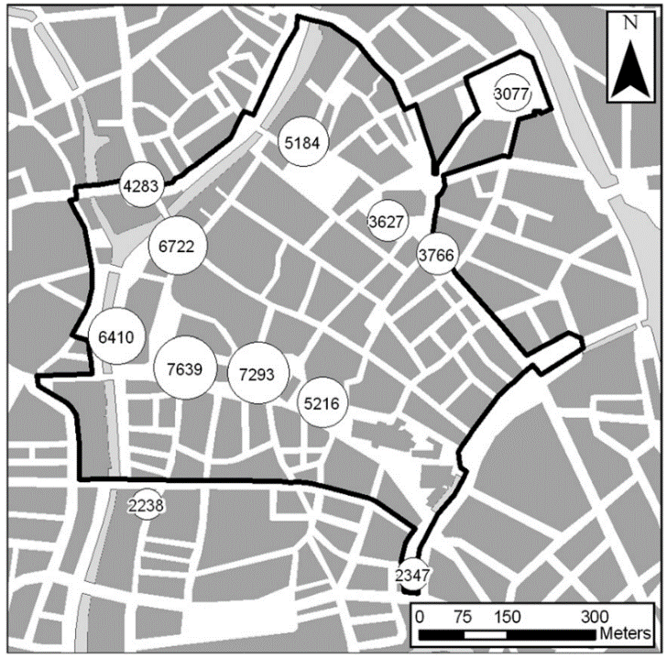

**Figure 3: Aggregated number of detected phones at public spaces during the Ghent Festivities (Versichele et al., (2012a)**

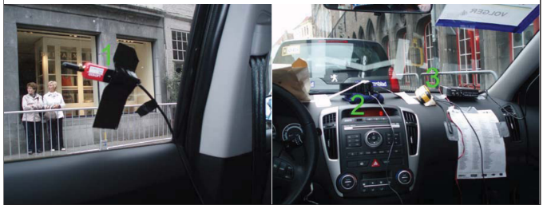 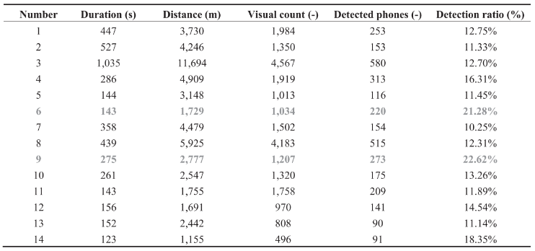

**Figure 4: The Bluetooth sensor (1), camera (2) and GPS (3) system installed inside a car to survey the number of detected phones versus the people during a road cycling race. The table shows the detection ratio of less than 15 % average accuracy (Versichele, 2012b)**

Methodology

This study attempts to estimate the number of student population in an academic building by combining the information of the number of Wi-Fi signals detected with the results from a survey conducted. In essence, simply counting the number of Wi-Fi enabled devices detected would not give an accurate prediction; people actually carry or use multiple devices simultaneously connected to Wi-Fi network. Thus, the survey would collect multiple or single device usage trends that would assist in increasing the prediction accuracy by a proposed adjustment.

Table 2 shows the survey results on the device usage trend. Every person uses their own mobile phone as shown in the Percentage of Usage column. Out of these, only 3.8 % uses two mobile phones. For laptop category, everyone uses only one laptop and they use them all the time inside the academic building. For tablet category, only 26.9 % of the student population uses them and only a single tablet was used each time.

**Table 2: Device Usage Trends in an Academic Building from the Survey Conducted on Students**

|  |  |  |  |  |
| --- | --- | --- | --- | --- |
| Device Type | Number of Devices Used Simultaneously | | | Percentage of Usage |
| 1 | 2 | 3 and above |  |
| Handphone | 96.2 % | 3.8 % | 0 % | 100 % |
| Laptop | 100 % | 0 % | 0 % | 100 % |
| Tablet | 100 % | 0 % | 0 % | 26.9 % |

### Figure 5 shows the amount of devices that students brought and used inside the campus. The relationship between the information from Table 2 and Figure 5 can be deduced as illustrated in Figure 6.

**Figure 5: Percentage of the Number of Devices Used Per person**

Raw Data

Wi-Fi Signal Capture Tool

Number of Devices

Number of Devices

16.7 % %

One Mobile Phone + One Laptop + One Tablet (96.2%)(*C*)

83.3 % %

One Mobile Phone

(*B*)

(*A*)

Two Mobile Phones + One Laptop + One Tablet (3.8 %)

One Mobile Phone + One Laptop

Three and four device usage

Single and two devices usage

Number of People

Number of People

Population Size Estimation

**Figure 6: Survey-based Methodology for Estimating the Number of People within the Area of Interest. *A*, *B* and *C* are parameters defined in the algorithm in (1)**

From Figure 6, the Survey-based Algorithm is generated as follows:

Population Size = $\left\lceil \frac{Raw Data × A}{2}\right\rceil$ + $\left\lceil \frac{Raw Data × B × C}{3}\right\rceil$ (1)

where *A* is the percentage of people using at most 2 Wi-Fi enabled devices, *B* is the percentage of people using at least 3 Wi-Fi enabled devices and *C* is the percentage of people using exactly 3 Wi-Fi devices.

The data collection campaign was performed in a 6-storey building with multiple routers in every level that provide complete coverage for the entire building. However, for validation purpose, only a single floor was selected for the test, as numerous rooms in each floor were inaccessible for real-time data collection. The Wi-Fi signal capture tool counted the number of Wi-Fi enabled devices which are connected to a specific SSID for students (Figure 7). The apparent advantage of this method is that the tool could crawl over multiple routers and capture all the Wi-Fi packets from the devices within the same SSID. The tool would lists all the devices’ name and type, if the information are available. Then, the algorithm is designed to predict the actual number of people from the collected data.

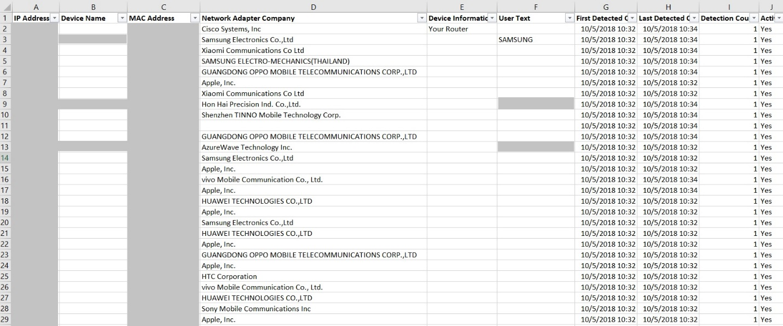

**Figure 7: Unsorted list of devices detected by the scanning tool**

Results and Discussion

Figure 8 shows the developed GUI written in C# language. To gauge the accuracy of the proposed algorithm, three small-sized site surveys were conducted and the results are tabulated in Table 3. Ground truth information is obtained by manually counting the people within the area defined and the results would be compared with the algorithm. As stated in Section 2, a medium to large scale verification could not be conducted due to the dynamicity of people’s movement and absence of full accessibility to each room within the building.

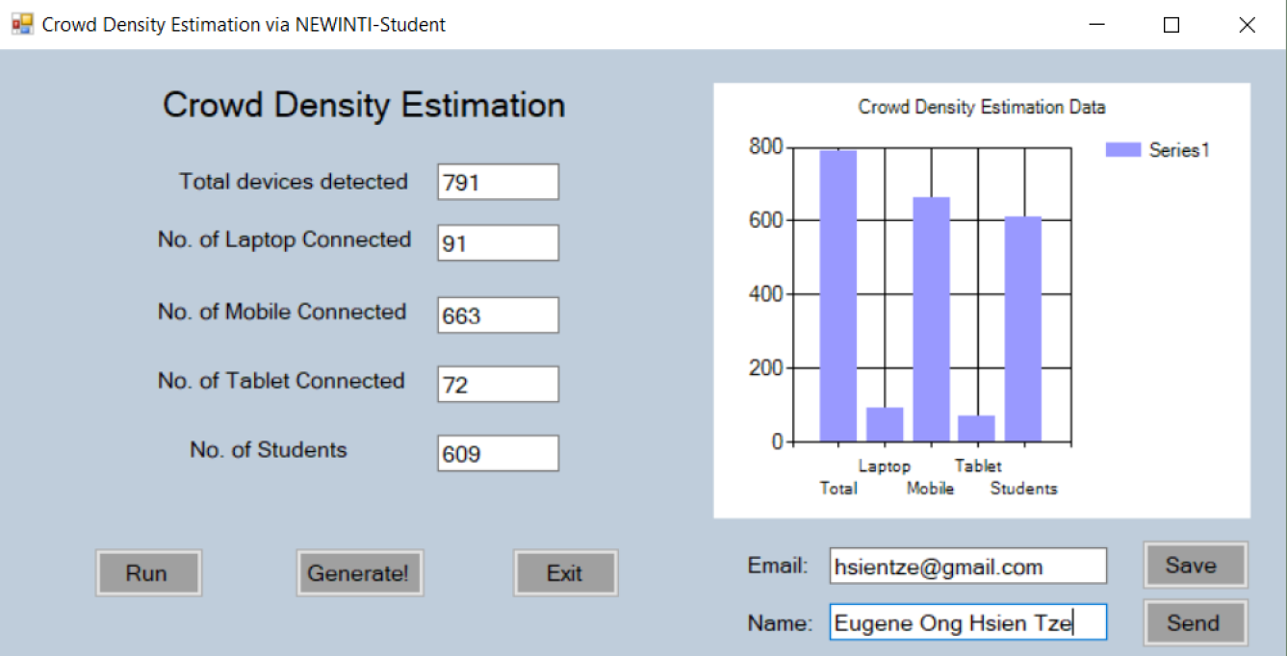

**Figure 8: GUI of the Crowd Size Estimation System developed using C#**

**Table 3: Prediction Accuracy of the Proposed Survey-based Algorithm**

|  |  |  |  |
| --- | --- | --- | --- |
| Site | Number of People | Prediction | Accuracy |
| Indoor – Single Access Point | 2 | 2 | 100 % |
| Indoor – Multiple Access Point | 23 | 21 | 91.3 % |
| Indoor – Multiple Access Points | 82* | 115 | 71.3 % |

*approximation is used as several rooms on the floor were inaccessible

**Conclusion**

Predicting the number of people inside a building using Wi-Fi signal detection has successfully been demonstrated from the proposed Survey-based Algorithm. The algorithm would depend on the survey on usage trends to determine the relevant parameters, denoted as A, B and C to increase prediction accuracy. The system is suitable to estimate medium scale building occupancies quickly with up to 71.3% accuracy, as long as there are Wi-Fi routers providing services to the users.

**References**

Depatla, S. & Mostofi, Y. (2018). Passive Crowd Speed Estimation and Head Counting Using WiFi Saandeep. 15th Annual IEEE International Conference on Sensing, Communication, and Networking (SECON).

Fadhlullah, S. Y. (2017). *Design And Implementation Of Human Crowd Density Estimation System With Energy Harvesting In Wireless Sensor Network Platform*. Unpublished PhD thesis. Universiti Sains Malaysia.

Fadhlullah, S. Y. & Ismail, W. (2016). A Statistical Approach In Designing An RF-Based Human Crowd Density Estimation System. *International Journal of Distributed Sensor Networks*, 12 (2).

Fadhlullah, S. Y. & Ismail, W. (2017). Path loss model for crowd counting. 7th IEEE International Conference on Control System, Computing and Engineering (ICCSCE).

Haochao, L., Chan, E. C. L., Xiaonan, G., Jiang, X., Kaishun, W., & Ni, L. M. (2015). Wi-Counter: Smartphone-Based People Counter Using Crowdsourced Wi-Fi Signal Data. *IEEE Transactions on Human-Machine Systems*, 45(4), 442-452.

Hiroi, K., Shinoda, Y. & Kawaguchi, N. (2016). A Better Positioning with BLE Tag by RSSI Compensation through Crowd Density Estimation. Proceedings of the 2016 ACM International Joint Conference on Pervasive and Ubiquitous Computing: Adjunct, 831-840.

Kura, S., Shiraishi, Y. & Yamaguchi, H. (2018) Low-cost Pedestrian Counter Using Wi-Fi APs for Smart Building Applications. IEEE 42nd Annual Computer Software and Applications Conference (COMPSAC), 640-645.

Tang, X., Xiao, B. & Li, K. (2018). Indoor Crowd Density Estimation Through Mobile Smartphone Wi-Fi Probes. *IEEE Transactions On Systems, Man, And Cybernetics: Systems*.

Versichele, M., Neutens, T., Delafontaine, M., & Van de Weghe, N. (2012a). The Use Of Bluetooth For Analysing Spatiotemporal Dynamics Of Human Movement At Mass Events: A Case Study Of The Ghent Festivities. *Applied Geography, 32*(2), 208-220.

Versichele, M. N., T.; Goudeseune, S.; van Bossche, F.; Van de Weghe, N. (2012b). Mobile Mapping of Sporting Event Spectators Using Bluetooth Sensors: Tour of Flanders 2011. *Sensors, 12*(10), 14196-14213.

Weppner, J., Lukowicz, P., Blanke, U. & Troster, G. (2014). Participatory Bluetooth Scans Serving as Urban Crowd Probes. *IEEE Sensors Journal*, 14(12), 4196-4206.

Xi, X., Zhao, J., Li, X-Y., Zhao, K., Tang, S., Liu, X., & Jiang, Z. (2014). Electronic Frog Eye: Counting Crowd Using Wi-Fi. IEEE Proceedings of INFOCOM, 361-369.

Xu, C., Firner, B., Moore, R. S., Zhang, Y., Trappe, W., Howard, R., & An, N. (2013). *SCPL: Indoor Device-Free Multi-Subject Counting And Localization Using Radio Signal Strength*. Paper presented at the Proceedings of the 12th International Conference On Information Processing In Sensor Networks, 79-90.

Yang, X., Yin, W. & Zhang, L. (2017). People Counting Based on CNN Using IR-UWB Radar. IEEE/CIC International Conference on Communications in China (ICCC).

Yuan, Y. (2014). Crowd Monitoring Using Mobile Phones. Sixth International Conference on Intelligent Human-Machine Systems and Cybernetics (IHMSC), 261-264.

Yuan, Y., Zhao, J. Z., Qiu, C., & Xi, W. (2013). Estimating Crowd Density in an RF-Based Dynamic Environment. *IEEE Sensors Journal, 13*(10), 3837-3845.